Project 3 Part 1 - Answered and coded by Landon Bird

1. Assuming that any vertex has a path connecting to the starting node, both DFS and BFS will be able to find it.
2. As in part A, both algorithms are capable of finding whether a path exists between two vertices.
3. No, BFS and DFS do not always find the same path between two vertices.

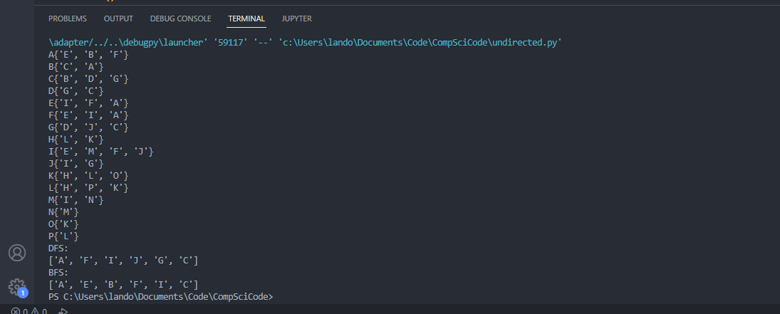

In this image, the start node was set to A and the end node was set to C. Both BFS and DFS were able to find the path between the nodes using different paths.

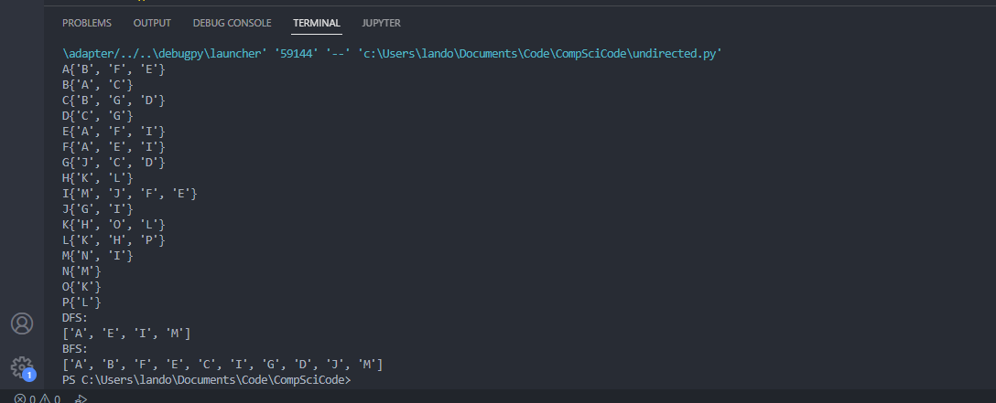

This image is the same procedure with A being the starting node and the end node being M. A path was found and the paths were vastly different.

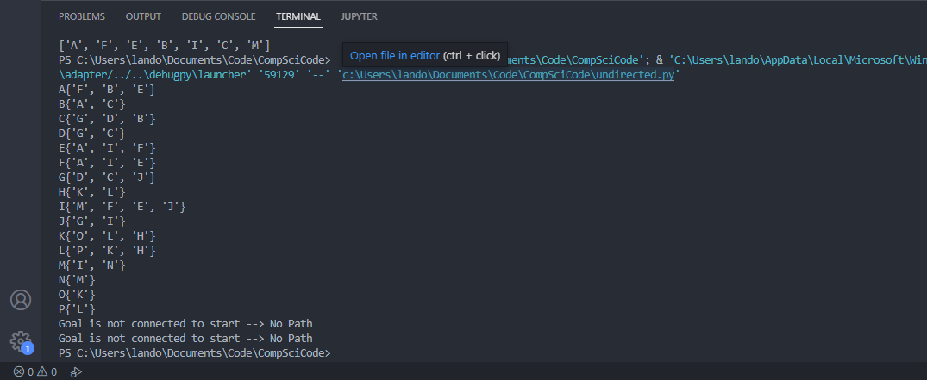

This time the goal was K, which does not have a path to the start node. This is recognized as a string output informing the user of the lack of connection.